Lab 3 Resistor Specifications
Pre-Lab Questions
Review the sample datasheet shown in Figure 1.0 and identify the following specifications:
- Nominal resistance
- Resistance tolerance
- Minimum allowable resistance
- Maximum allowable resistance
- Maximum power rating
- Operating temperature range
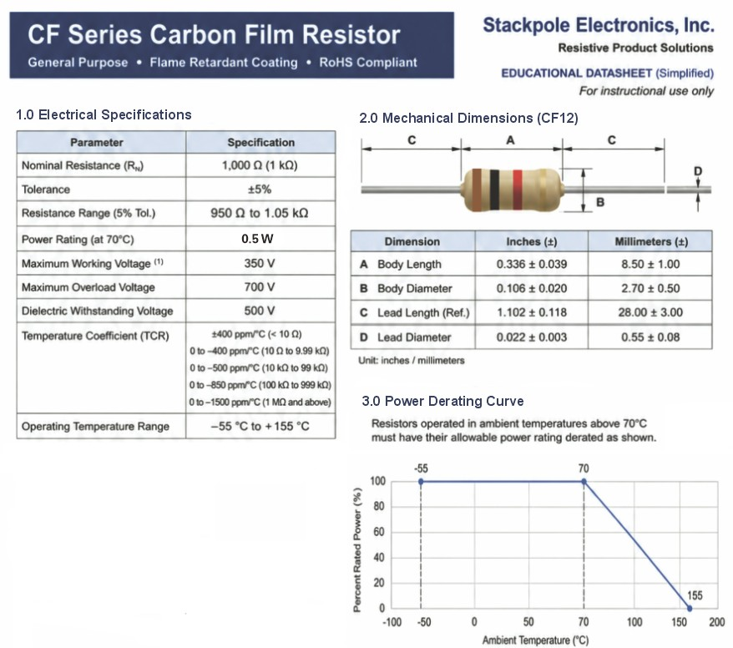
Figure 1.0 Simplified datasheet for a 1 kΩ, ±5%, 0.5 W carbon film resistor.
- What is the minimum allowable resistance for this 1 kΩ resistor with 5% tolerance?
R(min) = 1000-(0.05)(1000) so we get R(min) as 950 ohms .95k ohm

- What is the maximum allowable resistance for this 1 kΩ resistor with 5% tolerance?
R(max) = 1000 + (0.05)(1000) which gives us 1050 ohm 1.05k ohm

- What is the minimum allowable resistance for a 1 kΩ resistor with 1% tolerance?
R(min) = 1000-(.01)(1000) which gives 990 ohm or .99k ohm

- What is the maximum allowable resistance for a 1 kΩ resistor with 1% tolerance?
R(max) = 1000 + (.01)(1000) which give 1010ohm or 1.01k ohm

- A 1 kΩ resistor has a specified tolerance of ±1%. Its measured resistance is 1024 Ω. Does it meet the specification? Explain your answer.
no because 1% is 10ohms 24 ohms is 2.4% variation wince 2.4>1 its disqualified

- When measuring many 1 kΩ resistors with ±5% tolerance, would you predict that values are equally common throughout 950–1050 Ω, or more common near a central value? Describe your predicted distribution. Does the tolerance specification alone determine its shape? Explain.

- From the power derating curve in Figure 1.0, what is the maximum ambient temperature at which this resistor may dissipate its full rated power of 0.5 W?

- From the power derating curve in Figure 1.0, what is the maximum allowable power at an ambient temperature of 85°C?

- If the power supply in the lab is limited to a maximum voltage of 30 V per channel (on channels 2 and 3), how can you configure the instrument to create a voltage of 45 V?

- When measuring DC voltage with a DMM, is the meter connected in series or in parallel with the component being measured?

- When measuring resistance with a DMM, is the meter connected in series or in parallel with the component being measured?

- When measuring resistance with a DMM, can the component be powered by an external source?

- If the voltage across a resistor doubles, how does the power dissipation change? Explain using an equation.

- What is the equivalent resistance of three 10 kΩ resistors connected in parallel?

- A DC Power Supply with 40 V output is applied to three 10 kΩ resistors connected in parallel, together do these dissipate approximately the same power as the single 3.3 kΩ resistor? Show your equations.

